Team GitHub Link: https://github.com/princy123-git/sentiment-analysis-social-media-nlp

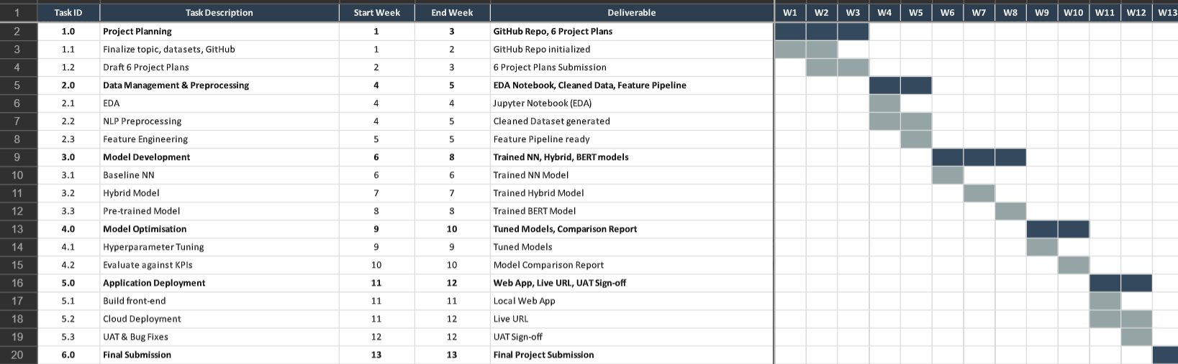

Project Tasks, Dates, and Deliverables
Task ID | Phase & Task Description | Start Date | End Date | Deliverable / Assessment
1.0 | Project Planning | Week 1 | Week 3
1.1 | Finalize topic, datasets, and GitHub setup | Week 1 | Week 2 | GitHub Repo initialized
1.2 | Draft 6 Project Plans | Week 2 | Week 3 | Assessment: 6 Project Plans Submission
2.0 | Data Management & Preprocessing | Week 4 | Week 5
2.1 | Data loading and exploratory data analysis (EDA) | Week 4 | Week 4 | Jupyter Notebook (EDA)
2.2 | NLP Preprocessing (Tokenization, Lemmatization) | Week 4 | Week 5 | Cleaned Dataset generated
2.3 | Feature Engineering (TF-IDF, Word Embeddings) | Week 5 | Week 5 | Feature Pipeline ready
3.0 | Model Development | Week 6 | Week 8
3.1 | Develop and train Baseline Neural Network (LSTM/DNN) | Week 6 | Week 6 | Trained NN Model
3.2 | Develop custom Hybrid Model (e.g., CNN + BiLSTM) | Week 7 | Week 7 | Trained Hybrid Model
3.3 | Implement Pre-trained Model (Transfer Learning/BERT) | Week 8 | Week 8 | Trained BERT Model
4.0 | Model Optimisation & Evaluation | Week 9 | Week 10
4.1 | Hyperparameter Tuning (GridSearch / Optuna) | Week 9 | Week 9 | Tuned Models
4.2 | Evaluate against KPIs (Compare the 3 models) | Week 10 | Week 10 | Model Comparison Report
5.0 | Application Deployment | Week 11 | Week 12
5.1 | Build front-end application (Streamlit / Flask) | Week 11 | Week 11 | Local Web App
5.2 | Cloud Deployment (Heroku / AWS / Streamlit Cloud) | Week 11 | Week 12 | Live URL
5.3 | User Acceptance Testing & Final Bug Fixes | Week 12 | Week 12 | UAT Sign-off
6.0 | Final Submission | Week 13 | Week 13 | Assessment: Final App and Codebase

